RPF New Material/Process Risk Assessment

Upload completed draft Risk Assessment to SydneyFMS.

I. New Process/Material details

Risk Assessment name: | Short description of the material and process / task  e.g. Hydrofluoric acid for wet etching of silicon oxide
Prepared by:
Date:
Materials involved | Material Name:  Material Form?  ☐ Liquid  ☐ Solid  ☐ Nano Particle  ☐ Gas
Is the material Hazardous? | ☐ Yes  ☐ No
Location: | ☐ RPF Cleanroom  ☐ 3021 Lab  ☐ Helium Ion Beam Microscope  ☐ Prototyping
Is this material/process necessary?  Can it be eliminated? | ☐ Yes  ☐ No – Why?
Are Substitutions available in RPF approved materials or processes?  Evaluate approved materials and processes in RPF by reviewing the approved RA & SWP or talk to one of the RPF team. | ☐ Yes  ☐ No – Why?

II. References
List of Legislation, Code of Practice, Australian Standards, and guidance materials used to determine control measures

List: Safety Data Sheets etc

III. Risk Assessment
Use this WHS website and the risk matrix to complete the risk assessment below:
http://sydney.edu.au/whs/activities/identify_hazards.shtml
https://intranet.sydney.edu.au/employment/safety-wellbeing/standards-guidelines/risk-management-steps.html

Guide
- Assess the potential hazard of each handling procedure from the information provided at Section III
- Assess the Risk of each potential hazard and provide the appropriate risk control for mitigation.
- On assessing the hazard and risk, we must follow this hierarchy of control
Eliminate the risk | Elimination | - Is this material/process necessary?
Reduce the risk | Substitution | - Have you considered lower risk alternative materials/processes  - Have you evaluated if the approved materials and processes in RPF have a viable alternative?  - Review the approved RA & SWP or talk to one of the RPF team.
Reduce the risk | Isolation | - What are the materials incompatible to this substance or it’s by-products?  - Do we have a dedicated working space to the risk of reaction to incompatible materials?  - Do we have a dedicated storage to the risk of reaction to incompatible materials?
Reduce the risk | Engineering | - How to minimize the hazard and risk by engineering controls  - Does the equipment have interlock sensors, automatic isolation?
Reduce the risk | Administrative | - SWP and certification
Reduce the risk | PPE | - Availability of appropriate PPEs

Risk Assessment Matrix Guide

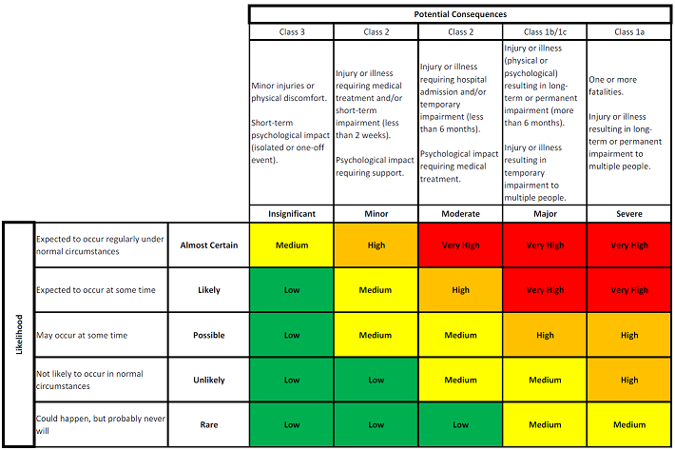

IV. Handling Procedure

Activities involved in handling this material |  | Material Concentration  (%) | Material Quantity  (volume) | Tool involved | Person at Risk
Transportation

Step 1

Step 2

Step 3
 | Insert additional rows for each new step

Decanting and Processing

Step 1

Step 2

Step 3
 | Insert additional rows for each new step

Storage Procedure

Step 1

Step 2

Step 3
 | Insert additional rows for each new step

Waste disposal procedure

Step 1

Step 2

Step 3
 | Insert additional rows for each new step

Does this material or process have a known hazardous by-product?
If so, list ways to eliminate or mitigate the hazard or risk

Step 1

Step 2

Step 3
 | Insert additional rows for each new step

Review RPF approved Risk assessments to review other examples

Task or scenario | Hazard/s | Associated harm  eg what could go wrong? | Existing Risk Controls | Current risk rating² | Any additional controls required? | Residual risk rating²
Elimination:
Substitution:
Isolation:
Engineering:
Administrative:
PPE:
Elimination:
Substitution:
Isolation:
Engineering:
Administrative:
PPE:
Elimination:
Substitution:
Isolation:
Engineering:
Administrative:
PPE:
Elimination:
Substitution:
Isolation:
Engineering:
Administrative:
PPE:

Always consider whether or not it is possible to eliminated the hazard or hazardous task altogether; if this is not possible, refer to the hierarchy of risk controls ² Use the Risk Matrix

